Connecting identification system to UMKa302

Technical support GLONASSSoft http://help.glonasssoft.ru,
e-mail: support@glonasssoft.ru
Tel: 8-800-700-82-21

Parameters for registering in GLONASSSoft :
1. Identificator – IMEI 0000000000000000 (SAMPLE)
2. Server IP address: 176.9.36.169
3. Port: 15050 (UMKa302)

Parameters for registering in Wialon:
- Identificator – IMEI 0000000000000000 (SAMPLE)
- Server IP address: 193.193.165.165
3. Port: 21336 (UMKa300), 21510 (UMKa301)

For partnership please contact
Tel.: 8-800700-82-21 free calls within Russia
e-mail: info@glonasssoft.ru

Connecting identification system

The reader can be connected to the tracker via RS-485 interface. In figure 1 the example of reader connection is represented. The resistor on the bus end is installed for aligning impedance and equals 120 ohm. It is recommended to implement RS-485 by a cable of “twisted pair” type. Together with the reader on the bus there can also be other devices (e.g. fuel level sensor).

The RS-485 branches to the readers must be as short as possible for complying with bus impedance. For corrosion prevention on the bus it is recommended to preliminary assign a unique address to each device.

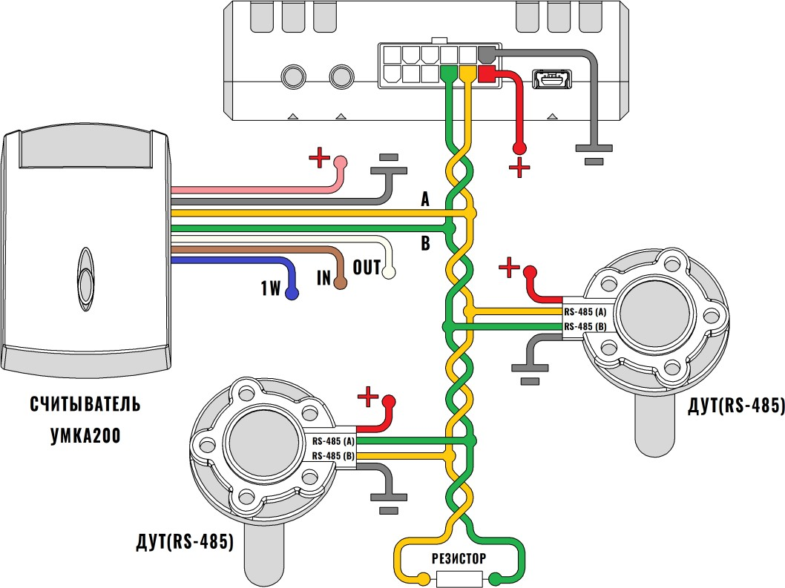

Figure 1 - Connecting the reader and FLS to the tracker

Attention! When working with trackers and FLSs the requirements of this operation manual are to follow strictly.

For proper operation of the tracker with the reader the tracker must be configured as follows: For connecting the devices with RS-485 interface to the tracker the tab “Interfaces” (Figure 2) is used. In this tab choose the mode “RFID” (for working with the reader only) or “FLS via LLS and RFID” (for connecting FLS via RS-485) from the dropdown menu, and in the “Speed” menu specify the operational speed of the interface (19200).
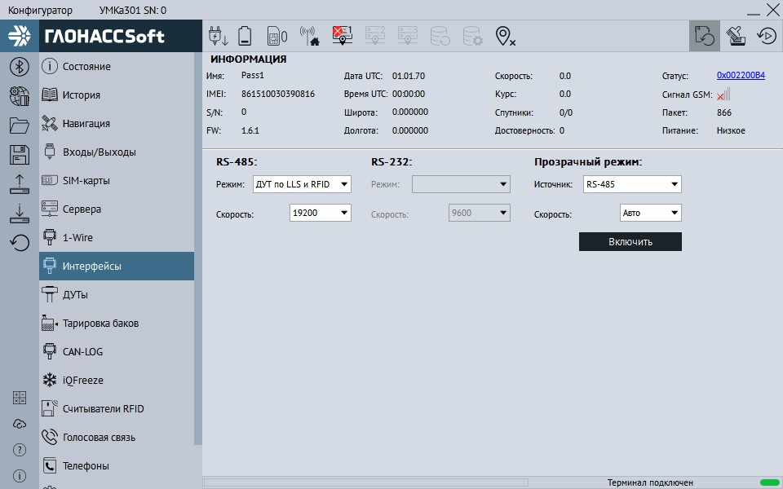
Figure 2 - “Interfaces” tab

To configure and receive information from fuel level sensors that use RS-485 interface use the tab “FLSs” (Figure 3), with a preliminary assignment of address to each sensor by corresponding configurator. To specify the addresses to the tracker it is sufficient to enter them in the field “Setting addresses of FLS-485” and download configuration into the tracker. Configurator automatically shows connected sensors and their parameters.
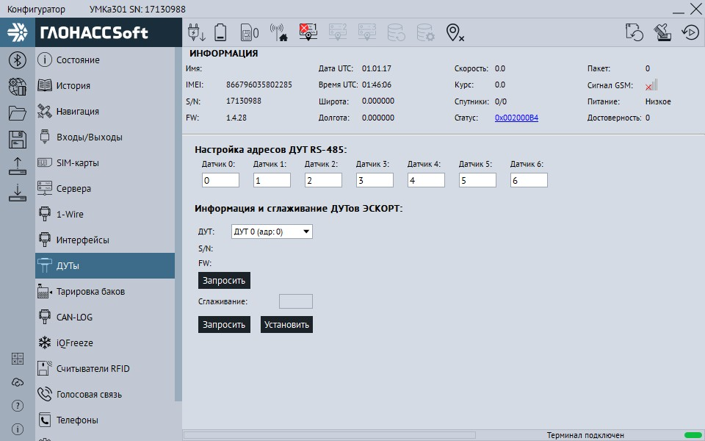

Figure 3 - “FLSs” tab

To configure and receive information from RFID cards with RS-485 interface use the tab “RFID reader” (Figure 4). To specify the addresses to the tracker it is sufficient to enter them in the field “Setting addresses of FLS-485” and download configuration into the tracker. To transmit the temperature tick opposite the corresponding reader’s field.

Attention! The readers’ addresses must not coincide with the ones of FLSs’.
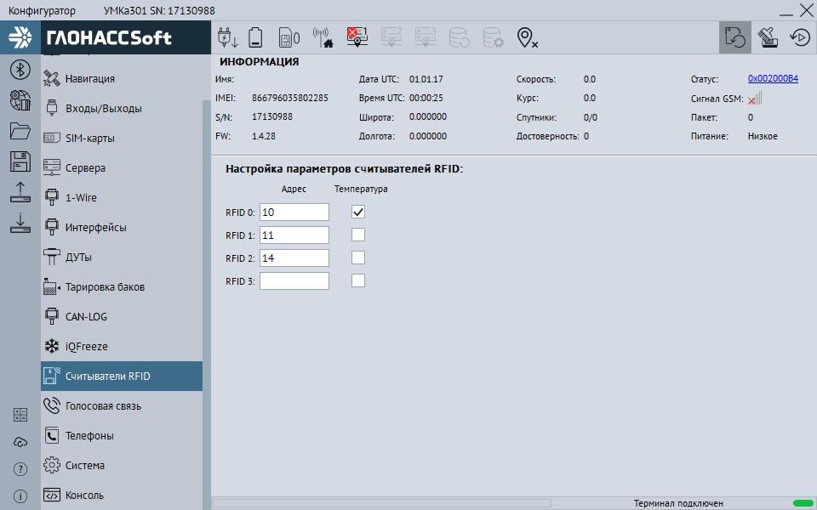
Figure 4 - “RFID reader” tab

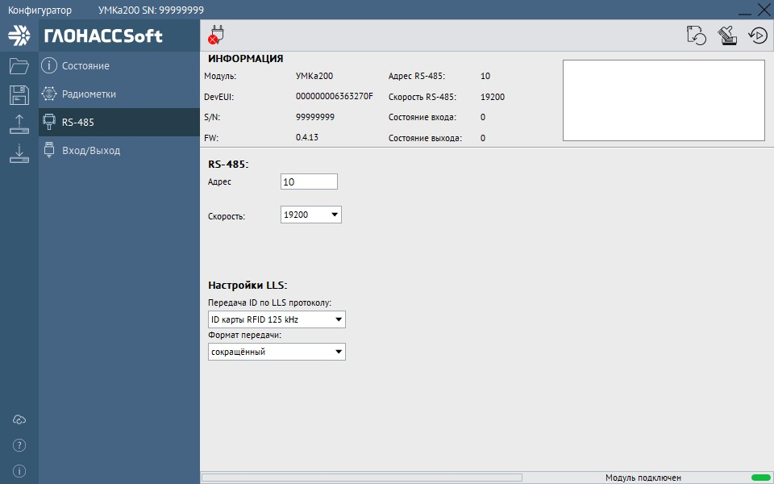
In UMKa200 configurator in the tab “RS-485” (Figure 5) the address and the reader’s speed must be configured. The address of the reader must coincide with the address entered into the tracker.
Figure 5 - “RS-485” tab

