ТНВЭД 8526 91 800 0

Contactless CAN reader UMKa210

PASSPORT

ВБРМ 054.000.000 ПС

1 BASIC INFORMATION AND TECHNICAL CHARACTERISTICS

Contactless CAN reader UMKa210 is designed to be installed in vehicles as intermediary device between the CAN bus and auxiliary equipment (for instance, a GPS tracker) that supports CAN interface.
UMKa210 scans CAN bus data in a non-contact way (without the need for direct insertion) and transmits them to auxiliary equipment. This way of connecting allows to save the manufacturer’s warranty and excludes the possibility for auxiliary equipment to affect the vehicle’s CAN bus.
Main technical characteristics are represented in Table 1.

Table 1 – Technical characteristics of UMKa210

Parameter | Value
Supply voltage, V | 8…40
Consumption current (at a voltage of 13,8 V), mA | < 20
Temperature range, °С | -40…+85
Dimensions, mm | 20x47
Transmission spee, Kbit/sec | 10-750
Case protecting rating | IP54

2 CONNECTION DESCRIPTION

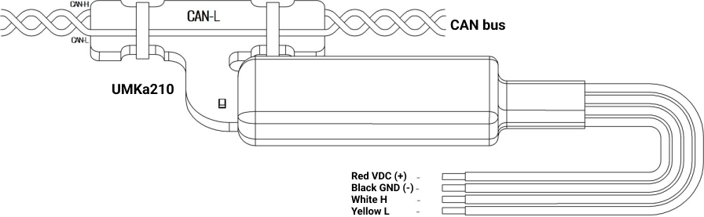

3 COMPLETENESS

Contents of delivery include:
- Reader – 1 unit
- Passport – 1 unit

4 WARRANTY LIFE AND MANUFACTURER WARRANTY

Warranty life – 5 years from the manufacture date. Warranty on the battery and external
antennas are submitted separately and last 1 year.
The manufacturer promises to repair the UMKa210 tracker free of charge within the
warranty period (or replace it with the device of a similar modification).
This warranty is legally valid when the device is submitted together with the rightly and
legibly completed complaint form (you can find the form at https://glonasssoft.ru). Customers
deliver the device to the place of repair by their own means.
The manufacturer shall not be liable for damages to property, or persons, or any other damages suffered by the UMKa210 owner or the third party due the failure to comply with
the rules of transportation, storage, installation and operation specified in the Operating Manual.
The tracker service life is 5 years except for battery and external antennas.
The warranty does not cover:
- defects caused by the failure to comply with the rules of transportation, storage,
installation and operation specified in the Operating Manual;
- connecting wires, slots, pins and SIM card holders;
- trackers without casing or with mechanical damages and defects (cracks and nicks, dents,
traces of blows, etc.) caused by the customers due to violating operating,storage and transportation conditions;
- trackers with traces of corrosion or other signs of fluid exposure;
- trackers with the signs of an unauthorized repair or upgrade;
- trackers with electrical and/or other damages due to the invalid condition of the external
electrical circuit or improper use of the tracker;
- trackers that failed due to unauthorized software updates.

5 PACKAGE
Contacless CAN reader UMKa210 has a group cardboard package. It is designed for 10 readers.

6 ACCEPTANCE CERTIFICATE

Contacless CAN reader UMKa210 with factory number and date of manufacture:

This product corresponds ТУ 26.30.11-001-29608716-2017 and is declared to be suitable for application.
Manufacturer: LLC “INTERNET VESHCHEY”
Address: Zipovskaya, d. 5, korp. 1, liter 2B Krasnodar, Krasnodar Region, Russia 350010
Website: http://glonasssoft.ru

7 TRANSPORTATION AND STORAGE

When transporting and storing, comply with the technical specifications TU 26.30.11-001-
29608716-2018. Transportation by water (besides sea) is carried out in a sealed package or in dry sealed compartments or containers. Transportation by air is carried out in the sealed compartments. After transporting the tracker at subzero temperatures, it is necessary to keep it at room temperature for 24 hours. Storage conditions in terms of climatic factors have to meet
storage conditions ОЖ4 ГОСТ 15150-69.

