Self-resetting fuse

PASSPORT
ВБРМ 048.000.000 ПС

1 BASIC INFORMATION AND TECHNICAL CHARACTERISTICS

Self-resetting fuse is designed for protecting electrical devices from short-circuit and overload current.
Main technical features are represented in Table 1.

Table 1 – Technical characteristics
Parameter | Value
Self-resetting fuse | Standard (middle) 3А
Maximum operational voltage | 32V
Current rating by t=20 °C | 0,55А
Minimum operating current | 1,10А
Operating time by current 3А | No longer than 0,2 sec
Wire material | Copper multicore
Wire cross-section | 0,5 мм²
Operational temperature | -40…+80 °С
Case protection rating | IP 54

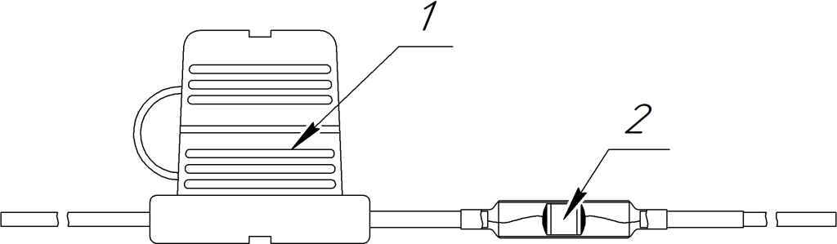
2 DESCRIPTION
Table 2: Self-resetting fuse
Input | Assignment
1 | Standard 3A fuse
2 | Self-resetting fuse

Contents of delivery include:
- Self-resetting fuse – 1 unit
- Passport – 1 unit

3 COMPLETENESS

4 PACKAGE

Self-resetting fuse is delivered in individual package of ZIP-lock type.

5 CLAIM
Manufacturer: LLC “NIS-GLONASS”
Address: Zipovskaya, d. 5, korp. 1, liter 2B Krasnodar, Krasnodar Region, Russia 350010
Website: http://glonasssoft.ru

2

